**Project Title: DineBot: An Autonomous Arduino Waitress for Restaurant Automation**

**Group Members**

20/02866 Justus Nzioki

20/03186 David Kiriago

20/02832 Collins Kathuli

20/03271 Alan Njogu

20/02770 Suzanne Njeri

20/03420 Ochieng Bryian

20/03043 Aaron Joseph

20/04217 Jane Mwangi

20/03749 Ouma Akinyi Lynn

20/04159 Hezekiel Kuloba

**Problem Addressed**

In the busy, crowded and active environment of a restaurant, efficient service plays a crucial role in enhancing the dining experience for customers. However, traditional waitstaff often face challenges in managing multiple orders, navigating through crowded spaces, and ensuring timely delivery of food. By introducing an Autonomous Arduino Waitress, DineBot tackles the inefficiencies inherent in traditional waiter service, such as delays in food delivery, human errors in order accuracy, and limitations in table-to-kitchen coordination. It aims to significantly reduce the time it takes to serve food, improve the accuracy of order delivery, and enhance the overall customer experience. With this automated solution, restaurants can ensure smoother operations, improved service quality, and ultimately, heightened customer satisfaction. Through dynamic navigation capabilities, DineBot will maneuver through the restaurant, accurately identify designated tables, and deliver food orders with precision. This innovative solution not only enhances operational efficiency but also addresses the growing demand for contactless service in the post-pandemic era, ensuring a safe and convenient dining experience for both customers and staff.

**Materials Required.**

**Arduino Uno**

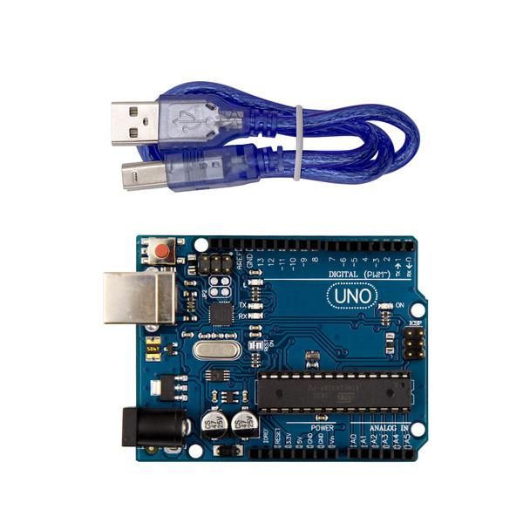

**Wheel Car Chassis**

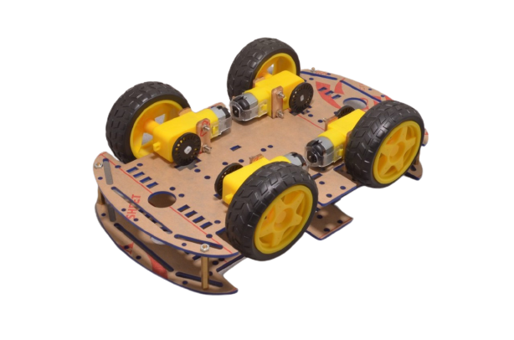

**Dc Motor**

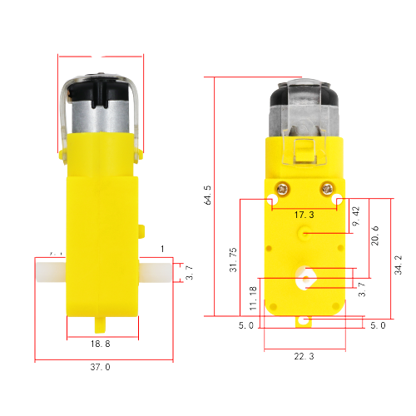

**Motor Driver**

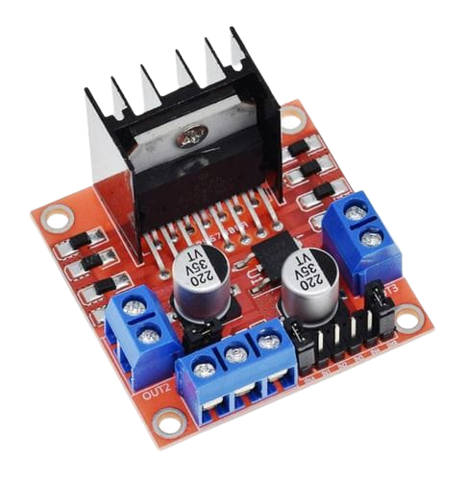

**Infrared Sensors**

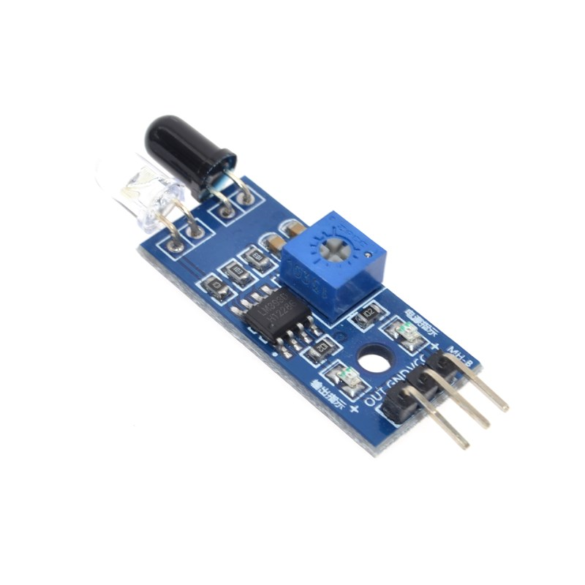

**DC Battery, 12 Volts**

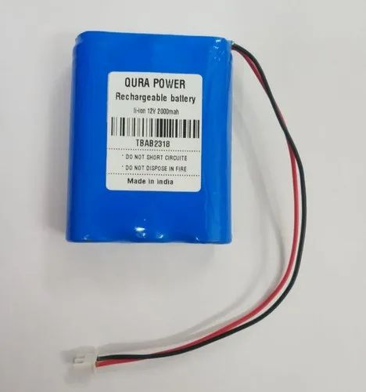

**Switch**

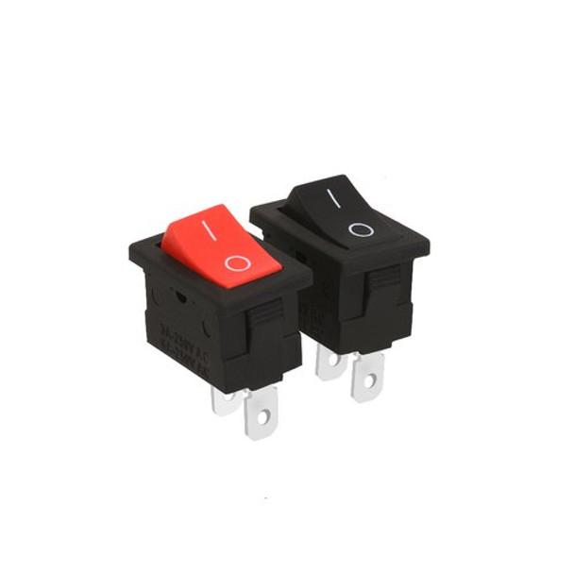

**How the Solution will be packaged**

The existing components, including the Arduino Uno, DC motors, infrared sensors, battery, and switch, will be securely connected together and mounted on a wheel chassis which will serve as the base for the robot. The components on the wheel chassis will then be covered with a sturdy plastic frame, ensuring proper alignment and protection of the components during operation.

A tray or platform will be attached to the top of the robot's frame. This tray will be responsible for holding and transporting food orders from the kitchen to the designated tables.

A simple user interface will be integrated into the robot's design, allowing restaurant staff to input table numbers or order details. This will be achieved through the use of buttons, a small LCD display, or even a touch screen interface.

**The use case of the solution**

1. Order Placement, Customers place their food orders through the restaurant's ordering system application. The order details, including the table number and specific dishes, are then transmitted to the Restaurant database system.
2. Order Processing, the restaurant staff will input table numbers and order details to Dinebot’s user interface which will be stored in its database.
3. Food Loading, The prepared food order is carefully loaded onto its tray or platform by the kitchen staff.
4. Navigation and Routing, DineBot calculates the shortest route from the kitchen to the designated table. It will avoid obstacles through the sensor and also follow laid out black lines on the restaurant floor to navigate to the specified table using infrared sensors.
5. Table Identification, As DineBot navigates through the restaurant, it utilizes a radio-based identification system to accurately locate the correct table where the order needs to be delivered. Each table in the restaurant is equipped with a unique radio transmitter that broadcasts a specific identification code or reference number.When a customer places an order, the table's reference number is associated with that order and stored in the DineBot system's database. This reference number is then transmitted to DineBot along with the order details. As DineBot approaches the seating area, it begins scanning for the radio signals emitted by the table transmitters. By comparing the received signals with the target reference number from the order, DineBot can pinpoint the precise table location where the order needs to be delivered.
6. Food Delivery, Upon reaching the designated table, DineBot stops and signals to the customers that their order has arrived. The customers can then retrieve their food from the robot's tray or platform.
7. Return to Kitchen, After successful food delivery, DineBot navigates back to the kitchen, ready to receive and deliver the next order.

**What is remaining in the project.**

Radio transmitter for individual restaurant tables, to assist DineBot to locate the tables.

Sturdy plastic frame for the packaging of DineBot inner components.

Ordering Application Linked to DineBot.

Database system for DineBot to receive customer order details.

**Conclusion**

With the appropriate funding DineBot can significantly improve the hospitality industry and restaurant customer satisfaction